**Comparing the Neighbourhoods of New York and Toronto**

**Prashant Gorade**

**November 24, 2019**

1. **Introduction**

* 1. **Background**

In this Capstone project I am exploring the similarities between the New York City and the city of Toronto. As Both cities are very diverse and are the financial capitals of their respective countries. One interesting idea would be to compare the neighbourhoods of the two cities and determine how similar or dissimilar they are from a tourist’s perspective.

* 1. **Problem Data**

The data that might contribute to this task would be extracted from foursquare REST API.

* 1. **Interest:**

Apart from hotels tourists find it very useful to know places where they can have good meals, breakfast and fun around so that they can have good time during their trips.

1. **Data acquisition and cleaning** 
   1. **Data sources**

As mentioned earlier I have used the foursquare data for this project. The data of neighbourhoods of these two cities will be segmented and clustered. I will segment and cluster their neighbourhoods. Queries that will be used to generate data are Food, Coffee, Nightlife, Shopping and Fun.

* 1. **Data cleaning**

The data extracted from four square website is cleaned for any non-numeric entries in the location fields. Fortunately, no such non-numeric value was found.

1. **Exploratory Data Analysis**
   1. **Comparison of Shopping and Night Life options**

The following plot shows the bar chart of shopping and nightlife options available in the cities under study within a radius of 10 km.

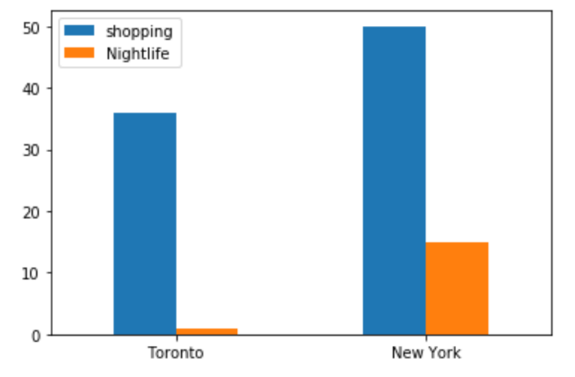

From the above plot it is seen that New York city significantly exceeds the city of Toronto in terms of options for shopping and Nightlife

* 1. **Comparison of Food, Coffee and Fun options**

The following plot shows the bar chart of shopping and nightlife options available in the cities under study within a radius of 10 km.

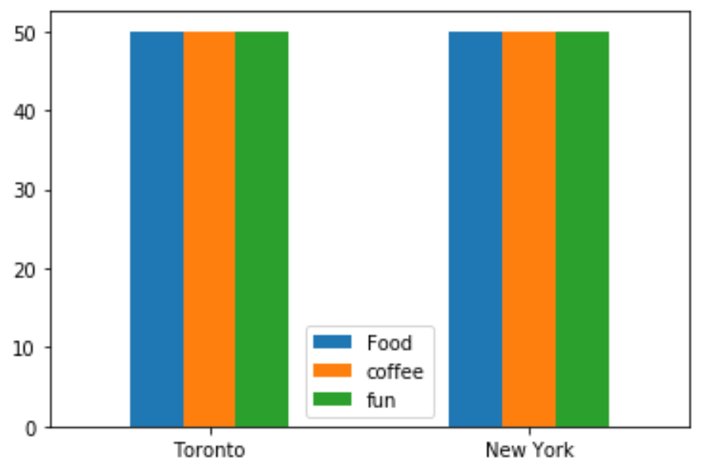

From the above plot it is easily seen that both cities are similar in terms of options available for food, coffee and fun.

* 1. **Clustering of Food options in Toronto**

The cluster plot of the variety of food options available in a radius of 10 km is shown in the picture below.

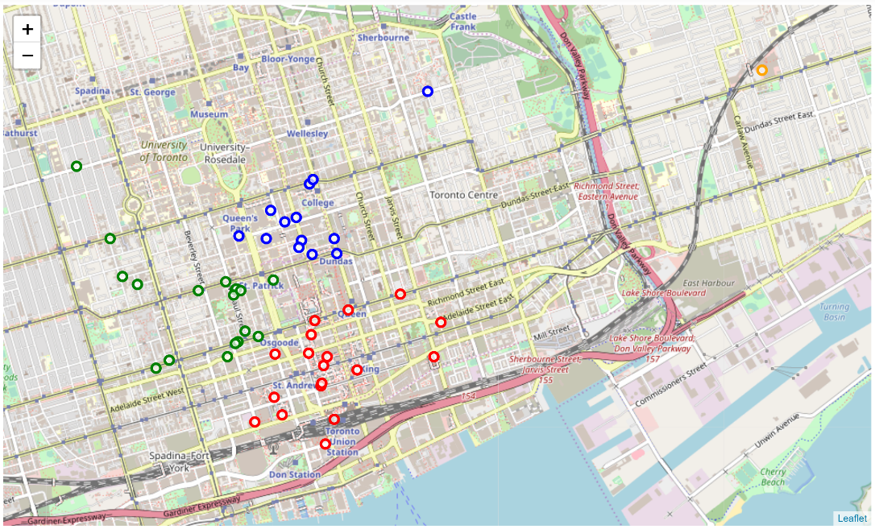

* 1. **Clustering of Food options in New York**

The cluster plot of the variety of food options available in a radius of 10 km is shown in the picture below.

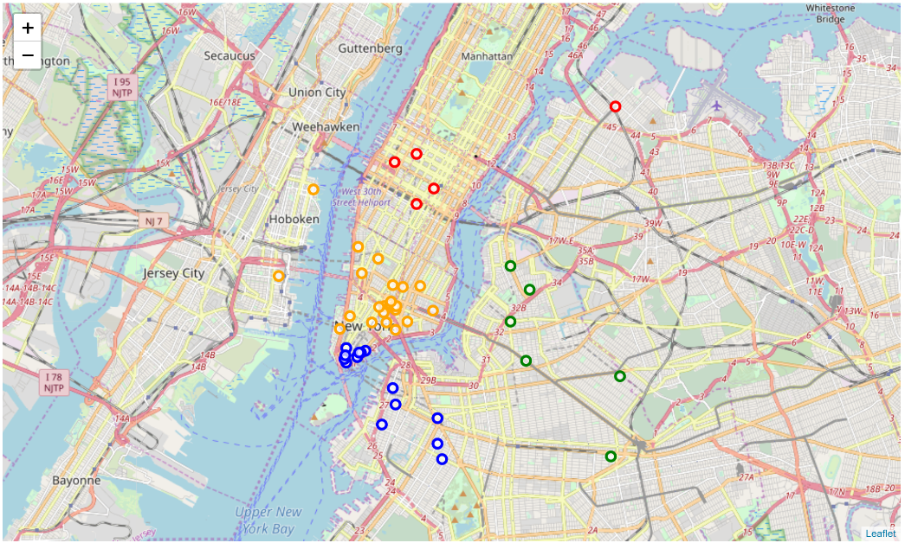

* 1. **Clustering of coffee options in Toronto**

The cluster plot of the variety of coffee options available in a radius of 10 km is shown in the picture below.

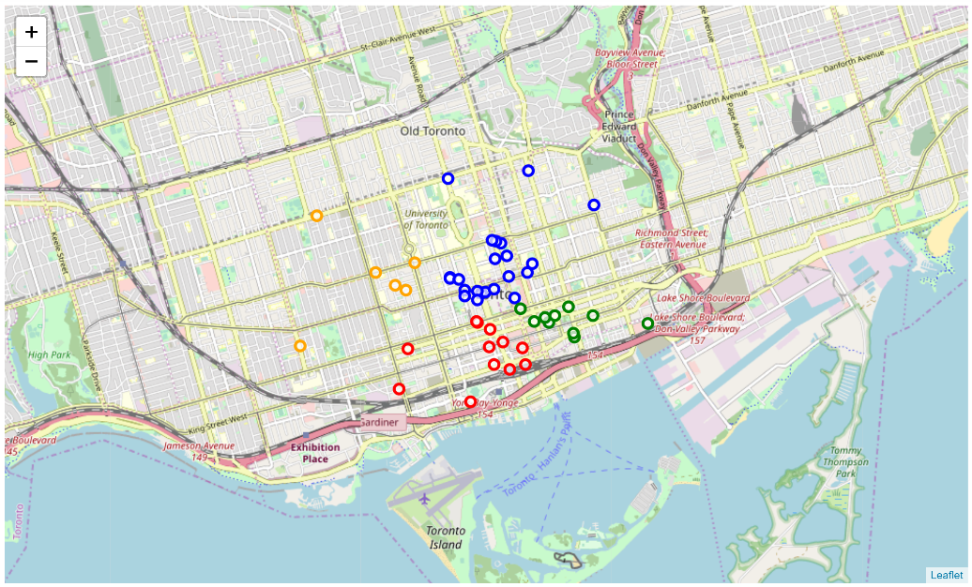

* 1. **Clustering of coffee options in New York**

The cluster plot of the variety of coffee options available in a radius of 10 km is shown in the picture below.

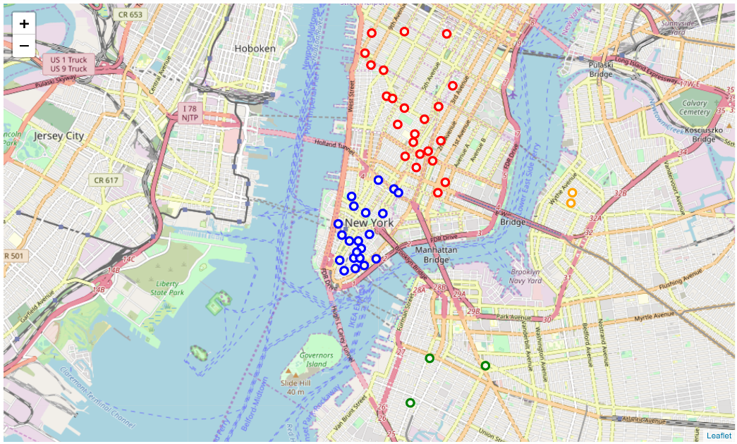

* 1. **Clustering of fun options in Toronto**

The cluster plot of the variety of fun options available in a radius of 10 km is shown in the picture below,

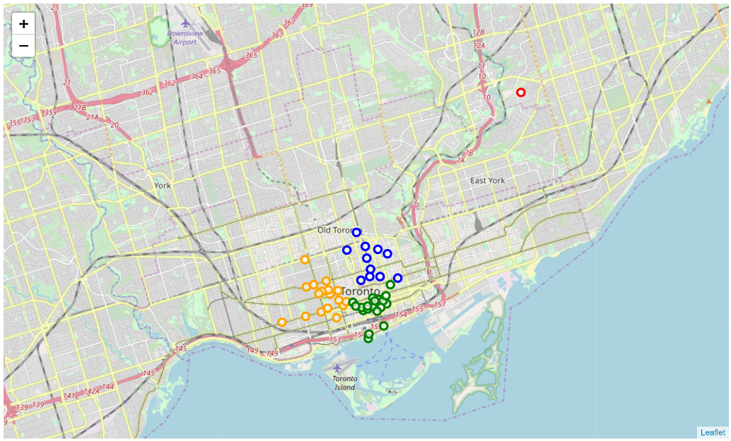

* 1. **Clustering of fun options in New York**

The cluster plot of the variety of fun options available in a radius of 10 km is shown in the picture below,

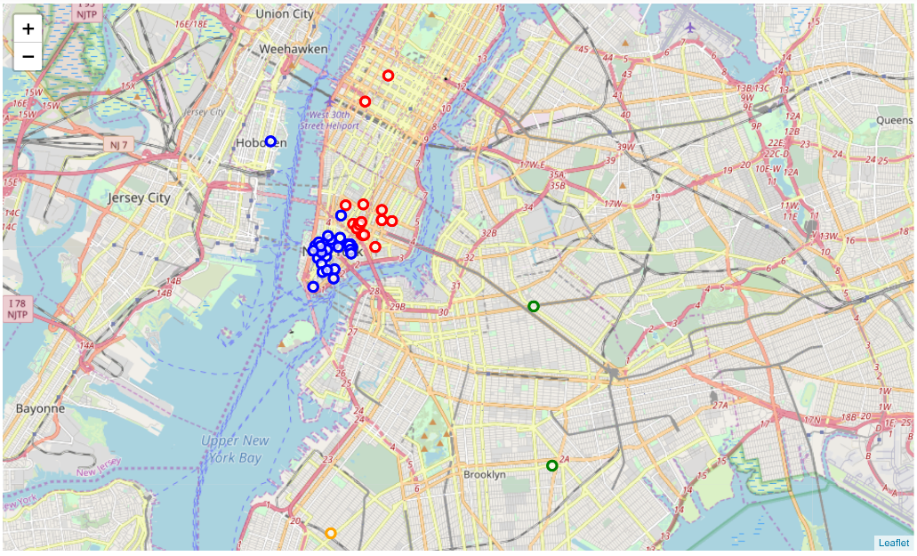

1. **Discussion**

The cluster plots show that both the cities have ample options for food, coffee and fun. The city of New York significantly exceeds in numbers when it comes to Nightlife and shopping. The fun options in both cities are closely spaced which means that the tourists wont miss visiting at least visiting a few of them. The summary of results has been shown below.

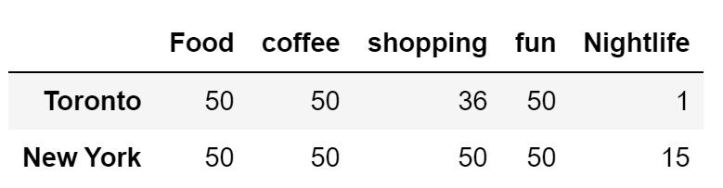

1. **Conclusion**

The neighbourhoods of New York and Toronto have been compared in this study on the basis of Food, Shopping, Coffee, Nightlife & Fun. A circular region of a radius of 10 km has been considered from the city centres for the study. The city of New York is seen to have higher numbers of Nightlife and shopping options compared to that of the city of Toronto. This study will also be helpful for new start-ups who plan to start businesses in these areas. Both cities have almost equal or comparable number of options when it comes to food, coffee and fun related activities.